**Can Singapore's social housing keep up with changing times?**

1. [REAL ESTATE](https://www.bbc.com/worklife/tags/real-estate" \t ")

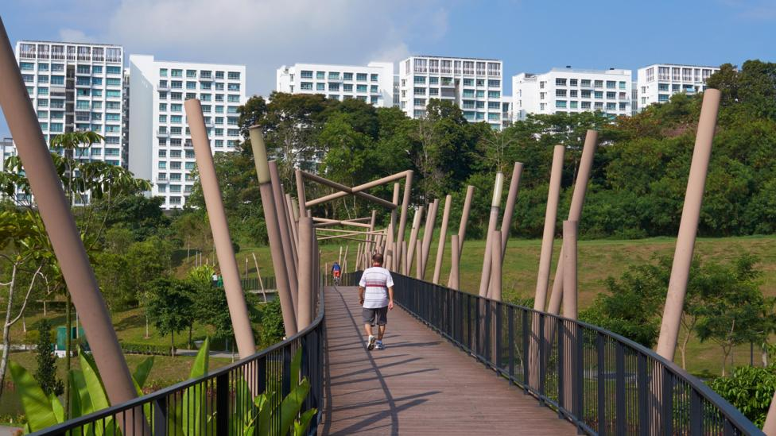

[Share on Facebook](https://www.facebook.com/sharer/sharer.php?u=https%3A%2F%2Fwww.bbc.com%2Fworklife%2Farticle%2F20181210-can-singapores-social-housing-keep-up-with-changing-times%3Focid%3Dww.social.link.facebook&t=Can%20Singapore%27s%20social%20housing%20keep%20up%20with%20changing%20times?" \t "_blank)

[Share on Twitter](https://twitter.com/intent/tweet?text=Can%20Singapore%27s%20social%20housing%20keep%20up%20with%20changing%20times?&url=https%3A%2F%2Fwww.bbc.com%2Fworklife%2Farticle%2F20181210-can-singapores-social-housing-keep-up-with-changing-times%3Focid%3Dww.social.link.twitter&via=BBC_Worklife" \t "_blank) [Share on Linkedin](https://www.linkedin.com/shareArticle?mini=true&url=https%3A%2F%2Fwww.bbc.com%2Fworklife%2Farticle%2F20181210-can-singapores-social-housing-keep-up-with-changing-times%3Focid%3Dww.social.link.linkedin&title=Can%20Singapore%27s%20social%20housing%20keep%20up%20with%20changing%20times?" \t "_blank)

[Share using Email](mailto:?subject=Shared%20from%20BBC:Can%20Singapore%27s%20social%20housing%20keep%20up%20with%20changing%20times?&body=https%3A%2F%2Fwww.bbc.com%2Fworklife%2Farticle%2F20181210-can-singapores-social-housing-keep-up-with-changing-times%3Focid%3Dww.social.link.email" \t "_blank)

Close navigation

**The kampongs of Singapore’s past are gone, replaced by high-rises built within its widely heralded public housing programme. But as times have changed, its requirements haven't.**



**By Sarah Keating**

14th December 2018

“I remember feeling very free. There was a lot of land to roam about,” says Chuck Hio Soon Huat. He sits at a table drinking coffee. “We built our own toys, climbed trees, walked in the river, shot birds, picked fruit.”

**Side note: What is Kampong**

A kampong or kampung (both Malay and Indonesian spelling) is a village in Brunei, Indonesia, Malaysia and Singapore and a "port" in Cambodia. ... Traditional kampongs are also a tourist attraction. The English word "compound" referring to a development in a town is from the Malay word kampung.

Hio reminisces about the past with his friend and former work colleague, Lam Chun See. The food court where they’re chatting is designed to look like one of Singapore’s many hawker centres, but a sentimental version – a pastiche with faded pastel awnings inside a modern shopping plaza.

The Singapore they remember is completely different from the contemporary city-state famous for its [**pristine streets**](http://www.bbc.com/capital/story/20181025-the-cost-of-keeping-singapore-squeaky-clean), sleek buildings and high-end malls.

They chat about growing up in kampongs (or kampungs), traditional villages of zinc-roofed wooden houses that often had no running water or electricity.

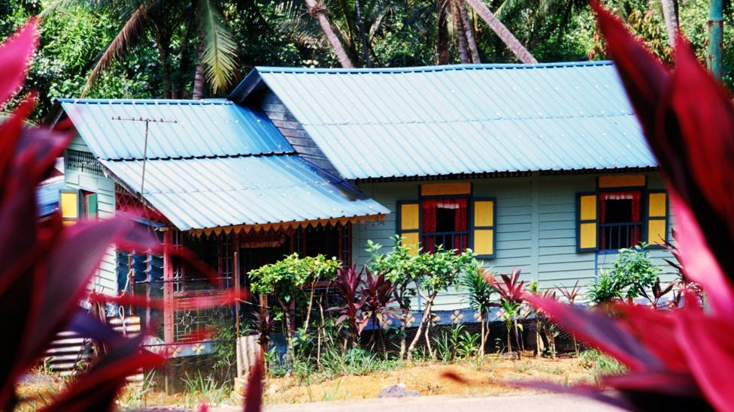

Today, kampongs have almost entirely disappeared in Singapore (Credit: Alamy)

Today, kampongs have almost entirely disappeared in Singapore, swept away by high-rises in what is seen as one of the world’s most ambitious and successful public housing programmes. But what drove this programme, and how well has it served Singapore’s generations?

**‘Talk less, do more’**

A push to build public housing began under the British in 1920. But the real change came in 1959 when the People’s Action Party (PAP) took power, says Han Ming Guang of the Singapore Heritage Society.

“There was a need to redevelop certain key areas of Singapore and also to re-house people away from the city as the PAP leaders wanted to make Singapore modern,” he says.

This process was accelerated after a fire at a kampong in 1961 left [**thousands of people homeless**](https://nuspress.nus.edu.sg/products/squatters-into-citizens), and deepened government concern about squalid and over-crowded living conditions.

In 1960, the [**Housing Development Board**](https://www.hdb.gov.sg/cs/infoweb/about-us/history) (HDB) was established and within three years had built more than [**31,000**](https://www.hdb.gov.sg/cs/infoweb/about-us/our-role/public-housing--a-singapore-icon) flats. With an ambitious mantra of ‘[**talk less, do more**](https://www.psd.gov.sg/heartofpublicservice/our-institutions/housing-a-nation-building-a-city/)’, hundreds of thousands of people were moved from kampongs into HDB flats, sparking mixed reactions.

“There were some who were delighted,” says Han. “These groups had been squatting or sharing a tiny space with others and had no electricity or modern sanitation. Moving into the HDB units was a godsend to them.”

But others resented having to move. “They chased us out,” says 66-year-old Lam Chun See, who writes a blog on his kampong days called [**Good Morning Yesterday**](http://goodmorningyesterday.blogspot.com/). “They took our land.”

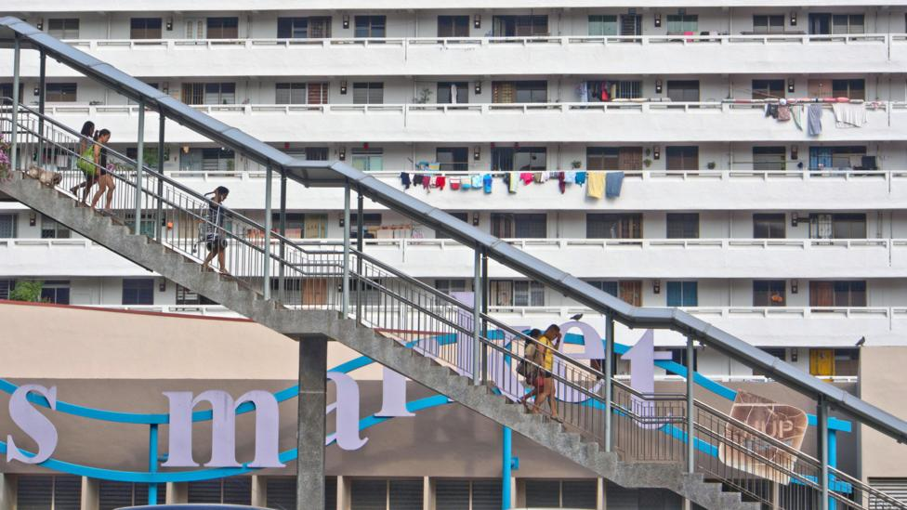

Singapore now has more than 1 million Housing Development Board (HDB) flats across 23 towns (Credit: Alamy)

Lam is referring to the Land Acquisition Act, which came into force the year after Singapore became independent in 1965. It was controversial but then Prime Minister Lee Kuan Yew insisted it was necessary. It enabled the government to acquire land at low cost for housing projects and move people out of the overcrowded city centre.

“The rationale of the Land Acquisition Act was that we ought to make sacrifices for the good of the country,” says Lam, “But if I [the government] take your land, that means I’m appointing you to make the sacrifice; to me that’s unfair.”

Chuck Hio Soon Huat remembers different emotions. “I didn’t feel sad at all, maybe I was too young. Shifting into an HDB flat felt better because it was much cleaner, much more convenient.”

HDBs were initially available only to rent, but home ownership soon became a national priority propelled by Lee Kuan Yew, who believed it would [**drive national stability**](http://www.nlb.gov.sg/biblioasia/2018/07/07/our-home-sweet-home/#sthash.h847G16a.dpbs).

After decades of intensive building, Singapore now has more than [**1 million HDB**](https://www.hdb.gov.sg/cs/infoweb/about-us/our-role/public-housing--a-singapore-icon) flats across 23 towns. In 1960 just 9% of Singaporeans lived in public housing; today that figure is nearly 80%, with more than [**90%**](https://www.singstat.gov.sg/find-data/search-by-theme/households/households/latest-data) of residents owning their homes.

Sale prices for new builds (Build-To-Order) are lower than market value – although there is a [**waiting period of at least 3 to 4 years**](https://www.hdb.gov.sg/cs/infoweb/hdbspeaks/reduce-waiting-time-for-bto-flats) before you can move in – and rental stock is [**heavily subsidised**](https://www.gov.sg/factually/content/how-is-hdb-helping-lowincome-households-with-a-roof-over-their-head) for low income households. Latest figures show that [**HDB flats make up 73%**](https://www.straitstimes.com/politics/parliament-hdb-flats-made-up-73-of-singapores-total-housing-stock-in-2016) of Singapore’s total housing stock.

**Pre-determined path?**

Safura Ashari, an estate agent who got into the business eight years ago after getting divorced, helps clients find HDB units.

The 40-year-old lives in an HDB in Pasir Ris in the east of Singapore. Uniform tower blocks line the road and there’s a buzzing food court, shops, a doctors’ surgery, a vet and a grocery store. The estate is alive with residents despite the tropical rain.

Singletons must wait until the age of 35 to buy and even then, can only purchase more expensive resale flats rather than new builds

Ashari says it’s a close-knit community. “I don’t lock my door, I make it a point to know my neighbours,” she says. “On my floor we have Indians, Chinese, Filipino and I’m Malay. We celebrate all the holidays – Hari Raya, Christmas, Diwali.”

The diversity is not a coincidence – each HDB has to meet strict ethnic quotas. The government’s [**Ethnic Integration Policy**](https://www.bbc.com/worklife/article/20181210-can-singapores-social-housing-keep-up-with-changing-times), implemented in 1989, aims to maintain an ethnic mix in HDBs, something [**Lee Kuan Yew said**](https://www.clc.gov.sg/docs/default-source/urban-solutions/urb-sol-iss-10-pdfs/essay-inclusion_through_intervention.pdf) would prevent communities “fragmenting and being alienated from one another”*.*

For estate agents like Ashari, this can prove tricky. “I had a case where I was selling the property for two years. The Malay quota was filled and it was a Chinese seller, so you can only sell to Chinese.”

Maintaining racial quotas is just one factor in accessing social housing. New HDB flats are [**only available to married couples**](https://services2.hdb.gov.sg/webapp/BP13EligCheck/BP13SHome?strSystem=CHECK). Singletons must wait until the age of 35 to buy and even then, can only purchase more expensive resale flats rather than new builds.

Divorcees also face hurdles – they can’t rent HDB flats for 30 months after selling the matrimonial home, limiting them to the more expensive open market, says Corinna Lim, executive director of AWARE (Association of Women for Action and Research). Unmarried mothers can also only buy HDBs once they hit 35 because they are not recognised as a “family nucleus”, she adds.

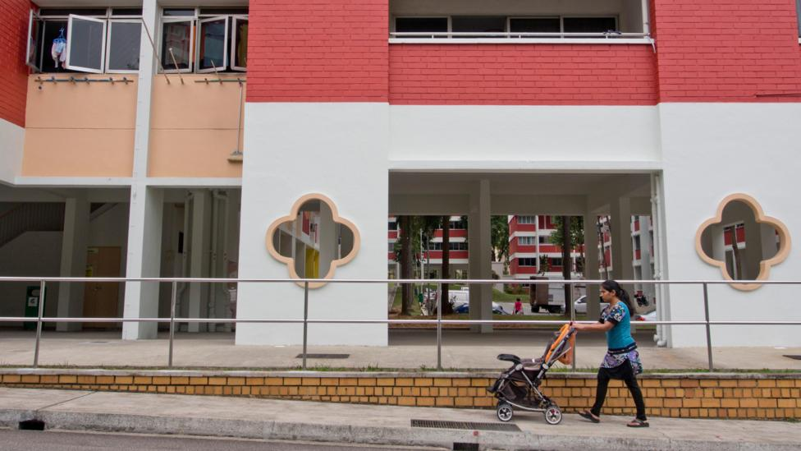

Unmarried Singaporean mothers can only buy HDBs once they hit 35 as they are not recognised as a “family nucleus” (Credit: Alamy)

The rationale is that less restrictive housing policy could encourage divorce and non-traditional family structures, but Lim says there is no “substantive evidence” to show divorce rates would increase if housing rules were relaxed.

“The reality is that there will always be divorced parents and unmarried mothers who need stable housing, regardless of the social or policy environment,” she says.

‘Steph’, who had a daughter at 17, says her need for a proper home is the same as any other family. “Family comes in different shapes and forms, and we need to start acknowledging it. Me being unwed doesn’t make me less of a mother or less of a Singaporean.”

Raymond Yeo, 43, was single when he bought his first home at the requisite age of 35. Now married and looking to upgrade his flat, he has mixed feelings about the system. He liked the original philosophy but feels that some of the criteria for buying an HDB need revisiting.

**Me being unwed doesn’t make me less of a mother or less of a Singaporean – ‘Sarah’**

“The government shows you paths they have created for you, so if you don’t conform, there’s nothing for you. If you want to own a home, you will try to get married and hopefully you can buy,” he says. “I feel the younger generation has no choice but to follow the path that is laid out for them.”

Ashari takes a different view despite having experienced her fair share of setbacks in life, and remains upbeat about the HDB system. “None of my clients have gone homeless, no matter what situation they are in,” she says, adding that it is common to appeal to the HDB and find a solution.

Home ownership is achievable mostly thanks to subsidies like grants [**to live close to your parents**](https://www.hdb.gov.sg/cs/infoweb/residential/buying-a-flat/resale/living-with-near-parents-or-married-child) and access to a [**Central Provident Fund**](https://www.mom.gov.sg/employment-practices/central-provident-fund/what-is-cpf) (CPF), a savings fund that all working Singaporeans are required to pay into. There are [**tight regulations**](https://www.hdb.gov.sg/cs/infoweb/residential/selling-a-flat/eligibility) around selling and renting out your HDB.

Ashari has seen clients’ attitudes change over the years, however. “The more conservative ones just want to have a roof over their heads,” she says, “but there is another group that want a good HDB in a good location. They say: ‘I’m going to stay there for five years [as mandated by law] and then I’m going to rent it out and I’m going to buy another private property [on the open market].’”

**Keeping communities connected**

Tan Jin Meng, a 53-year-old with a Master's Degree in Public Policy from the Lee Kuan Yew School of Public Policy, has taken a broader look at Singapore’s housing policy. [**Amid rising debate**](https://www.channelnewsasia.com/news/singapore/budget-2018-debate-wp-sylvia-lim-speech-inequality-9999876) on inequality in the city-state, he points out that the public housing provision constitutes a “very significant social benefit”.

But he says housing has become a political tool – a social contract between Singaporeans and a government obliged to keep providing homes for them. “It is a millstone because the government is now ‘responsible’ – it can’t reduce benefits without [political] cost.”

And Tan is worried for the future. [**He fears some people are over-extending**](https://www.channelnewsasia.com/news/commentary/emphasis-home-ownership-hdb-lease-review-of-public-housing-10423116) on housing, leaving few retirement savings. He also feels older people are becoming isolated, even though HDB blocks were designed to encourage neighbourliness.

In Pasir Ris, Ashari says she chose her current estate because it has a [**garden**](http://www.bbc.com/capital/story/20181210-gardening-could-be-the-hobby-that-helps-you-live-to-100), fitness area, basketball courts, four playgrounds and activities like Zumba and badminton. Such design features encourage people to come together, but Tan believes the kampong spirit is eroding amid a new mindset in younger generations.

“We are not a very gregarious people,” he says. “We tend to keep to ourselves, so the government has a lot of concerns about reaching out to people and getting them involved in activities.”

**The question popped is not “Will you marry me?” but “Want to get a flat together?”**

Tan also feels that future generations – better educated than their parents, with higher incomes and fewer children - may want different things from their housing.

One thing they may not be happy about is that all HDB flats come with a 99-year lease. Once it runs out, the government can reclaim them. Singapore’s a young nation and what happens when the first leases run out is a [**hotly-debated topic**](https://www.straitstimes.com/singapore/a-99-year-leasehold-flat-is-an-owned-asset-not-a-rental-lawrence-wong).

[**It is also often said**](https://millennialsofsg.com/2017/01/12/bto-first-meaningful-proposal/) that in Singapore the question popped is not “Will you marry me?” but “Want to get a flat together?”.

Angela Oh, 29, bought her new four-room HDB with the man who is now her husband in 2012 and just moved in this year. The system allows partners to put their names down for new flats, but you must be married by the time it is built.

“The long time that BTOs (Built to Order) take to build really spoils the joy of the proposal,” she says, because marriage becomes about practicality. [**If you break up**](https://blog.moneysmart.sg/property/applying-bto-breaking/) during the waiting period, you lose money and are barred from applying for another BTO for a year.

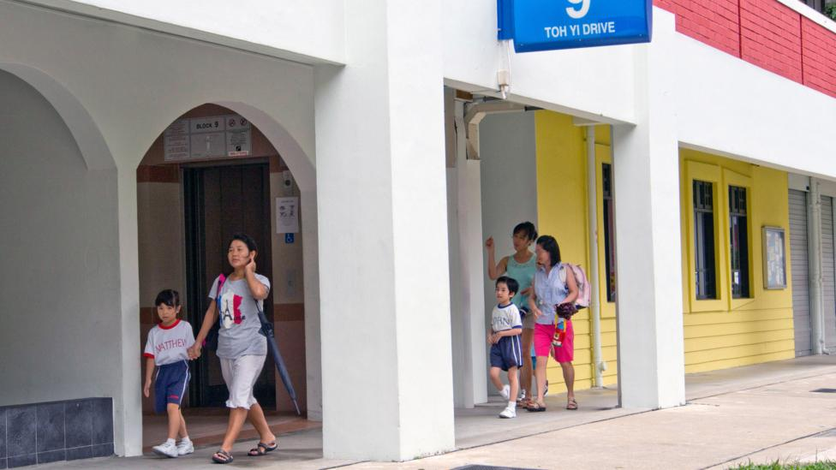

"I don’t lock my door, I make it a point to know my neighbours,” says Safura Ashari, an estate agent who helps clients find HDB units (Credit: Alamy)

Oh, who grew up in an HDB, says she and her husband “are content to make a forever home out of our BTO”. But she says her generation think differently to their parents.

“Our parents probably believe that an HDB flat is the be all and end all,” she says. “The current generation has more to think about than just having a roof over their heads… global citizenship has redefined the way we view and think about the location of a home.”

For former kampong-dwellers like Lam Chun See and Chuck Hio Soon Huat, there will always be a pull to the past.

“We had nature at our doorstep,” says Lam. “Here, what doorstep? [In your] HDB flat, you don’t have a doorstep!” he laughs. “But the fault is not with the HDB,” he continues. “It’s urbanisation.”

Hio nods his head. “It’s the price you pay for progress,” he says. “But I feel proud that we played a part in it.”

*To comment on this story or anything else you have seen on BBC Capital, please head over to our* [**Facebook**](https://www.facebook.com/BBCCapital) *page or message us on*[**Twitter**](https://twitter.com/BBC_Capital)*.*

*If you liked this story, sign up for the weekly bbc.com features*[***newsletter***](http://pages.emails.bbc.com/subscribe/)*called "If You Only Read 6 Things This Week". A handpicked selection of stories from BBC Future, Culture, Capital and Travel, delivered to your inbox every Friday.*